UNITED STATES

SECURITIES AND EXCHANGE COMMISSION

Washington, D.C. 20549

FORM 6-K

REPORT OF FOREIGN PRIVATE ISSUER

PURSUANT TO RULE 13a-16 OR 15d-16 UNDER

THE SECURITIES EXCHANGE ACT OF 1934

For the month of May 2025

Commission File Number: 001-38638

NIO Inc.

(Registrant’s Name)

Building 19, No. 1355, Caobao Road, Minhang District

Shanghai, People’s Republic of China

(Address of Principal Executive Offices)

Indicate by check mark whether the registrant files or will file annual reports under cover Form 20-F or Form 40-F.

Form 20-F ☒ Form 40-F ☐

 |  |  |  |  |  |  |  |  | EXHIBIT INDEX
Exhibit No. |  |  |  |  |  |  |  |  | Description
 | 99.1 |  |  | Press Release
 | 99.2 |  |  | Notice of Annual General Meeting
 | 99.3 |  |  | Proxy Card for Annual General Meeting
 | 99.4 |  |  | Voting Card for ADS Holders
 | 99.5 |  |  | CDP Depositor Proxy Form

SIGNATURES

Pursuant to the requirements of the Securities Exchange Act of 1934, the registrant has duly caused this report to be signed on its behalf by the undersigned, thereunto duly authorized.

NIO Inc.
By | : | /s/ Yu Qu
Name | : | Yu Qu
Title | : | Chief Financial Officer

Date: May 22, 2026

Exhibit 99.1

NIO to Hold Annual General Meeting on June 24, 2026

Shanghai, May 22, 2026 -- (GLOBE NEWSWIRE) -- NIO Inc. (NYSE: NIO; HKEX: 9866; SGX: NIO) (“NIO” or the “Company”), a pioneer and a leading company in the global smart electric vehicle market, today published a notice to announce that it will hold an annual general meeting (the “AGM”) of shareholders (the “Notice of AGM”) at 10:30 a.m., Beijing time, on June 24, 2026 at Building 19, No. 1355, Caobao Road, Minhang District, Shanghai, People’s Republic of China, for the purposes of considering and, if thought fit, passing the proposed resolutions set forth in the Notice of AGM (the “Proposed Resolution”). The Notice of AGM and form of proxy for the AGM are available on the Company’s website at https://ir.nio.com/generalmeeting. The board of directors of NIO fully supports the Proposed Resolutions and recommends that shareholders and holders of ADSs vote in favor of the Proposed Resolutions.

Holders of record of ordinary shares of the Company at the close of business on May 22, 2026 (Hong Kong time) are entitled to attend and vote at the AGM or any adjournment or postponement thereof. Holders of the Company’s American depositary shares (“ADSs”) as of the close of business on May 22, 2026 (New York time) who wish to exercise their voting rights for the underlying Class A ordinary shares must act through the depositary of the Company’s ADS program, Deutsche Bank Trust Company Americas. Holders of Class A ordinary shares which are held through (either directly or through depository agents) securities accounts (the “NIO CDP Depositors”) maintained with The Central Depository (Pte) Limited (“CDP”) (Singapore) as of the close of business on May 22, 2026 (Singapore time) may be appointed as CDP’s proxy to attend and cast votes at the AGM, or provide instructions as to voting, or abstentions from voting to CDP. NIO CDP Depositors may refer to the Notice of AGM for further information on attendance and voting arrangements.

NIO has filed its annual report on Form 20-F, including its audited financial statements, for the fiscal year ended December 31, 2025, with the U.S. Securities and Exchange Commission (the “SEC”). NIO’s Form 20-F can be accessed on the Company’s website at https://ir.nio.com, as well as on the SEC’s website at http://www.sec.gov.

About NIO Inc.

NIO Inc. is a pioneer and a leading company in the global smart electric vehicle market. Founded in November 2014, NIO aspires to shape a sustainable and brighter future with the mission of “Blue Sky Coming”. NIO envisions itself as a user enterprise where innovative technology meets experience excellence. NIO designs, develops, manufactures and sells smart electric vehicles, driving innovations in next-generation core technologies. NIO distinguishes itself through continuous technological breakthroughs and innovations, exceptional products and services, and a community for shared growth. NIO provides premium smart electric vehicles under the NIO brand, premium smart electric vehicles for families through the ONVO brand, and small smart high-end electric cars with the FIREFLY brand.

Safe Harbor Statement

This press release contains statements that may constitute “forward-looking” statements pursuant to the “safe harbor” provisions of the U.S. Private Securities Litigation Reform Act of 1995. These forward-looking statements can be identified by terminology such as “will,” “expects,” “anticipates,” “aims,” “future,” “intends,” “plans,” “believes,” “estimates,” “likely to” and similar statements. NIO may also make written or oral forward-looking statements in its periodic reports to the SEC, in its annual report to shareholders, in announcements, circulars or other publications made on the websites of each of The Stock Exchange of Hong Kong Limited (the “SEHK”) and the Singapore Exchange Securities Trading Limited (the “SGX-ST”), in press releases and other written materials and in oral statements made by its officers, directors or employees to third parties. Statements that are not historical facts, including statements about NIO’s beliefs, plans and expectations, are forward-looking statements. Forward-looking statements involve inherent risks and uncertainties. A number of factors could cause actual results to differ materially from those contained in any forward-looking statement, including but not limited to the following: NIO’s strategies; NIO’s future business development, financial condition and results of operations; NIO’s ability to develop and manufacture vehicles of sufficient quality and appeal to customers on schedule and on a large scale; its ability to ensure and expand manufacturing capacities including establishing and maintaining partnerships with third parties; its ability to provide convenient and comprehensive power solutions to its customers; the viability, growth potential and prospects of the battery swapping, BaaS, and NIO Assisted and Intelligent Driving and its subscription services; its ability to improve the technologies or develop alternative technologies in meeting evolving market demand and industry development; NIO’s ability to satisfy the mandated safety standards relating to motor vehicles; its ability to secure supply of raw materials or other components used in its vehicles; its ability to secure sufficient reservations and sales of its vehicles; its ability to control costs associated with its operations; its ability to build its current and future brands; general economic and business conditions globally and in China and assumptions underlying or related to any of the foregoing. Further information regarding these and other risks is included in NIO’s filings with the SEC and the announcements and filings on the websites of each of the SEHK and SGX-ST. All information provided in this press release is as of the date of this press release, and NIO does not undertake any obligation to update any forward-looking statement, except as required under applicable law.

For more information, please visit: http://ir.nio.com

Investor Relations

ir@nio.com

Media Relations

global.press@nio.com

2

Exhibit 99.2

NIO Inc.

(A company controlled through weighted voting rights and

incorporated in the Cayman Islands with limited liability)

(NYSE: NIO; HKEX: 9866; SGX: NIO)

Notice of Annual General Meeting

to be held on June 24, 2026

(or any adjournment(s) or postponement(s) thereof)

NOTICE IS HEREBY GIVEN that an annual general meeting (the “AGM”) of NIO Inc. (the “Company”) will be held at 10:30 a.m., Beijing time, on June 24, 2026 at Building 19, No. 1355, Caobao Road, Minhang District, Shanghai, People’s Republic of China, for the purposes of considering and, if thought fit, passing each of the following resolutions:

AS ORDINARY RESOLUTIONS

- To re-elect Mr. Hai Wu as an independent director of the Company.

- To appoint PricewaterhouseCoopers and PricewaterhouseCoopers Zhong Tian LLP as the auditors of the Company to hold office until the conclusion of the next annual general meeting of the Company and to authorize the Board to fix their remuneration for the year ending December 31, 2026.¹

The passing of the above resolutions requires approval by the holders of the Class A ordinary shares of a par value of US$0.00025 each (the “Class A Ordinary Shares”) and the Class C ordinary shares of a par value of US$0.00025 each (the “Class C Ordinary Shares,” and together with the Class A Ordinary Shares, the “Shares”) of the Company by a simple majority of the votes cast by the shareholders as, being entitled to do so, vote in person or by proxy at the AGM, on a one share one vote basis.

The quorum of the AGM shall be one or more members holding in aggregate at least one-third of all votes attaching to all issued shares of the Company, present in person or by proxy and entitled to vote at the AGM.

SHARES RECORD DATE AND ADS RECORD DATE

The Board has fixed the close of business on May 22, 2026 (Hong Kong time), as the record date (the “Shares Record Date”) of Class A Ordinary Shares and Class C Ordinary Shares. Holders of record of the Shares (as of the Shares Record Date) are entitled to attend and vote at the AGM and any adjourned meeting thereof.

Holders of record of American Depositary Shares (the “ADSs”) as of the close of business on May 22, 2026 (New York time) (the “ADS Record Date,” together with the Shares Record Date, the “Record Date”) will be able to instruct Deutsche Bank Trust Company Americas, the depositary of the ADSs, as to how to vote the Class A Ordinary Shares represented by such ADSs at the AGM.

- Taking into account the current scope and complexity of the audit work, the expected audit timetable, professional expertise and auditors’ resources required, the estimated audit fee for the year ending December 31, 2026 is expected to be within the range of approximately RMB12.5 million to RMB14.5 million, which is exclusive of out-of-pocket expenses, tax and related surcharges. based on the assumption that there will be no material change in our operations, business plan, audit scope or applicable regulatory requirements, and no additional non-recurring audit work arising from any material transaction, acquisition or other similar event, during the year ending December 31, 2026.

1

Holders of Class A Ordinary Shares which are held through (either directly or through depository agents) securities accounts (the “NIO CDP Depositors”) maintained with The Central Depository (Pte) Limited (“CDP”) (Singapore) as of the close of business on the Shares Record Date may be appointed as CDP’s proxy to attend and cast votes at the AGM, or provide instructions as to voting, or abstentions from voting to CDP. For further information, see “Attending the AGM.”

ATTENDING THE AGM

Only holders of record of Shares as of the Shares Record Date are entitled to attend and vote at the AGM.

Holders of ADSs must give voting instructions to Deutsche Bank Trust Company Americas if they wish to exercise their voting rights for the underlying Class A Ordinary Shares.

NIO CDP Depositors who:

- wish to be appointed as CDP’s proxy to attend and cast votes at the AGM; or

- do not wish to attend the AGM as CDP’s proxy but wish to provide instructions as to voting, or abstentions from voting,

should complete and return the AGM depositor proxy form, which will be mailed to the NIO CDP Depositors and is also available on our website at https://ir.nio.com/generalmeeting (the “AGM Depositor Proxy Form”), to Boardroom Corporate & Advisory Services Pte. Ltd. (“Boardroom”), the Singapore transfer agent of the Company, by 5:00 p.m., Singapore time, on June 17, 2026. For the avoidance of doubt, NIO CDP Depositors who do not complete and return the AGM Depositor Proxy Form by 5:00 p.m., Singapore time, on June 17, 2026, will not be able to attend or vote at the AGM, or provide instructions as to voting, or abstentions from voting.

NIO CDP Depositors who have queries on the above instructions should contact Boardroom via the following for assistance:

Boardroom Corporate & Advisory Services Pte. Ltd.

Address: 1 Harbourfront Avenue, #14-07 Keppel Bay Tower, Singapore 098632

Telephone: (+65) 6536 5355

E-mail: srs.proxy@boardroomlimited.com

In relation to paragraphs (a) and (b) above, NIO CDP Depositors should further note that they will only be able to be appointed as CDP’s proxy and/or exercise their voting rights in respect of such number of Class A Ordinary Shares set out against their respective names in the depository register maintained by the CDP as at the Shares Record Date.

PROXY FORMS, ADS VOTING CARDS AND DEPOSITOR PROXY FORMS

A holder of Shares as of the Shares Record Date may attend the AGM in person or appoint one proxy to exercise his or her rights at the AGM. A holder of ADSs as of the ADS Record Date will need to instruct Deutsche Bank Trust Company Americas, the depositary of the ADSs, as to how to vote the Class A Ordinary Shares represented by the ADSs. NIO CDP Depositors can exercise their voting rights in the manner set out in paragraphs (a) or (b) above under the section titled "Attending the AGM" by submitting the completed AGM Depositor Proxy Form to Boardroom. Please refer to the proxy form (for holders of Shares), ADS voting card (for holders of ADSs) or AGM Depositor Proxy Form (for NIO CDP Depositors), each of which is available on our website at https://ir.nio.com/generalmeeting.

You are urged to complete, sign, date and return the accompanying proxy form to the Company’s Hong Kong branch share registrar and transfer office, Computershare Hong Kong Investor Services Limited (“Computershare”) (for holders of Shares), your voting instructions to Deutsche Bank Trust Company Americas (for holders of the ADSs), and the AGM Depositor Proxy Form to Boardroom (for NIO CDP Depositors) as promptly as possible and before the prescribed deadline if you wish to exercise your voting rights. Computershare must receive the proxy form by no later than 10:30 a.m., Hong Kong time, on June 22, 2026 at 17M Floor, Hopewell Centre, 183 Queen’s Road East, Wan Chai, Hong Kong, to ensure your representation at the AGM. Deutsche Bank Trust Company Americas must receive your voting instructions by no later than 10:00 a.m., New York time, on June 10, 2026 to enable the votes attaching to the Shares represented by your ADSs to be cast at the AGM. To exercise their voting rights in the manner set out at paragraphs (a) or (b) above under the section titled “Attending the AGM,” NIO CDP Depositors must return the completed AGM Depositor Proxy Form to Boardroom by no later than 5:00 p.m., Singapore time, on June 17, 2026.

ANNUAL REPORT

Shareholders may obtain a copy of the Company’s annual report, free of charge, from the Company’s website at https://ir.nio.com, the HKEX’s website at www.hkexnews.hk or from the SEC’s website at www.sec.gov, or by contacting Investor Relations Department, NIO Inc., Building 19, No. 1355, Caobao Road, Minhang District, Shanghai, People’s Republic of China, or by email to ir@nio.com.

 | By Order of the Board of Directors,
 | NIO Inc.
 | /s/ Bin Li
 | Bin Li
 | Chairman of the Board
Executive Office: | Registered Office:
Building 19, No. 1355, Caobao Road | PO Box 309, Ugland House, Grand Cayman,
Minhang District, Shanghai | KY1-1104, Cayman Islands
People’s Republic of China
May 22, 2026

Exhibit 99.3

NIO Inc.

(A company controlled through weighted voting rights and

incorporated in the Cayman Islands with limited liability)

(NYSE: NIO; HKEX: 9866; SGX: NIO)

Form of Proxy for Annual General Meeting

to be held on June 24, 2026 at 10:30 a.m., Beijing time

(or any adjournment(s) or postponement(s) thereof)

INTRODUCTION

This Form of Proxy is furnished in connection with the solicitation by the board of directors (the “Board”) of NIO Inc., a Cayman Islands company (the “Company”), of proxies from holders of the issued Class A ordinary shares of the Company with a par value of US$0.00025 per share (the “Class A Ordinary Shares”) and the Class C ordinary shares of the Company with a par value of US$0.00025 per share (the “Class C Ordinary Shares”, and together with the Class A Ordinary Shares, the “Ordinary Shares”) to be exercised at the annual general meeting of the Company (the “AGM”) to be held at Building 19, No. 1355, Caobao Road, Minhang District, Shanghai, People’s Republic of China on June 24, 2026 at 10:30 a.m. (Beijing Time), and at any adjournment(s) or postponement(s) thereof, for the purposes set forth in the Notice of the AGM (the “AGM Notice”).

Only the holders of record of the Ordinary Shares on the Company’s register of members at the close of business on May 22, 2026 (Hong Kong Time), as the record date, are entitled to attend and to vote at the AGM. In respect of the matters requiring shareholders’ vote at the AGM, each Class A Ordinary Share and each Class C Ordinary Share is entitled to one vote. The quorum of the AGM is one or more shareholders holding in aggregate at least one-third of all votes attaching to all issued shares of the Company, present in person or by proxy and entitled to vote at the AGM.

The Ordinary Shares represented by all properly executed proxies returned to the Company will be voted at the AGM as indicated or, if no instruction is given, the holder of the proxy will vote the Ordinary Shares in his/her/its discretion, unless a reference to the holder of the proxy having such discretion has been deleted and initialed on this Form of Proxy. Where the chairman of the AGM acts as proxy and is entitled to exercise his/her discretion, he/she is likely to vote the Ordinary Shares FOR the resolutions. As to any other business that may properly come before the AGM, all properly executed proxies will be voted by the persons named therein in accordance with their discretion. The Company does not presently know of any other business which may come before the AGM. However, if any other matter properly comes before the AGM, or any adjournment(s) or postponement(s) thereof, which may properly be acted upon, unless otherwise indicated the proxies solicited hereby will be voted on such matter in accordance with the discretion of the proxy holders named therein. Any person giving a proxy has the right to revoke it at any time before it is exercised by (i) submitting to the Company, at the address set forth below, a duly signed revocation or (ii) voting in person at the AGM.

To be valid, this Form of Proxy must be completed, signed and returned to Computershare Hong Kong Investor Services Limited at 17M Floor, Hopewell Centre, 183 Queen’s Road East, Wan Chai, Hong Kong as soon as possible and no later than 10:30 am, Hong Kong time, on June 22, 2026, to ensure your representation at the AGM.

This Form of Proxy is not valid for holders of the American Depositary Shares of the Company or holders of Class A Ordinary Shares which are held through (either directly or through depository agents) securities accounts (the “NIO CDP Depositors”) maintained with The Central Depository (Pte) Limited (Singapore). Holders of the American Depositary Shares of the Company and NIO CDP Depositors should refer to the AGM Notice for further information on attendance and voting arrangements.

NIO Inc.

(A company controlled through weighted voting rights and incorporated in the Cayman Islands with limited liability)

(NYSE: NIO; HKEX: 9866; SGX: NIO)

Form of Proxy for Annual General Meeting^{(Note 1)}
to be held on June 24, 2026 at 10:30 a.m., Beijing time

(or any adjournment(s) or postponement(s) thereof)

I/We (name) of (address) , being the registered holder of Class A ordinary shares, ^{(Note 2)} par value US$0.00025 per share, and Class C
ordinary shares, ^{(Note 2)} par value US$0.00025 per share, of NIO Inc. (the “Company”), hereby appoint the Chairman of the Annual General Meeting^{(Note 3)} or

(name) of (address) as my/our proxy to attend and act for me/us at the Annual General Meeting (or at any adjournment(s) or postponement(s) thereof) of the Company to be held at Building 19, No. 1355, Caobao Road, Minhang District, Shanghai, People’s Republic of China and at any adjournment(s) or postponement(s) thereof, and in the event of a poll, to vote for me/us as indicated below, or if no such indication is given, as my/our proxy thinks fit.

(Note 4)

 | RESOLUTIONS^{(Note 5)} | _{FOR}(Note 4) | AGAINST^{(Note 4)} | ABSTAIN^{(Note 4)}
1 | As an ordinary resolution: | ☐ | ☐ | ☐
 | to re-elect Mr. Hai Wu as an independent director of the Company.
2 | As an ordinary resolution: | ☐ | ☐ | ☐
 | to appoint PricewaterhouseCoopers and PricewaterhouseCoopers Zhong Tian
 | LLP as the auditors of the Company to hold office until the conclusion of the
 | next annual general meeting of the Company and to authorize the Board to fix
 | their remuneration for the year ending December 31, 2026.

Dated _______________, 2026 Signature(s) ^{(Note 6)} ____________________

Notes:

- This Form of Proxy is not valid for holders of the American Depositary Shares of the Company or holders of Class A Ordinary Shares which are held through (either directly or through depositary agents) securities accounts (the “NIO CDP Depositors”) maintained with The Central Depository (Pte) Limited (Singapore). Holders of the American Depositary Shares of the Company and NIO CDP Depositors should refer to the AGM Notice for further information on attendance and voting arrangements.

- Please insert the number of shares registered in your name(s) to which this proxy relates. If no number is inserted, this form of proxy will be deemed to relate to all the shares in the Company registered in your name(s).

- If any proxy other than the Chairman is preferred, strike out the words “THE CHAIRMAN OF THE ANNUAL GENERAL MEETING” and insert the name and address of the proxy desired in the space provided. A member may appoint one or more proxies to attend and vote in his/her stead. ANY ALTERATION MADE TO THIS FORM OF PROXY MUST BE INITIALED BY THE PERSON(S) WHO SIGN(S) IT.

- IMPORTANT: IF YOU WISH TO VOTE FOR THE RESOLUTION, TICK THE APPROPRIATE BOX MARKED “FOR.” IF YOU WISH TO VOTE AGAINST THE RESOLUTION, TICK THE APPROPRIATE BOX MARKED “AGAINST.” ALTERNATIVELY, YOU MAY ALSO INDICATE THE RESPECTIVE NUMBERS OF SHARES FOR EACH OF THE “FOR,” “AGAINST” AND “ABSTAIN” COLUMNS. Failure to complete any or all the boxes will entitle your proxy to cast his or her votes at his or her discretion. A proxy need not be a member of the Company, but must attend the Meeting in person. A member may only have one form of proxy valid at any one time and if a member submits more than one form of proxy, the last form of proxy received in the manner described in this form of proxy above shall be treated as the only valid form of proxy. Any alteration made to this form of proxy must be duly initialed by the person who signs it. Completion and deposit of a form of proxy does not prevent a member from attending the Meeting in person but if a member attends the Meeting and votes, this proxy will be revoked.
- Please refer to the AGM Notice for details of the approval threshold for each of the resolutions.

- This form of proxy must be signed by you or your attorney duly authorized in writing or, in the case of a corporation, must be either executed under its common seal or under the hand of an officer or attorney or other person duly authorized to sign the same.

Exhibit 99.4
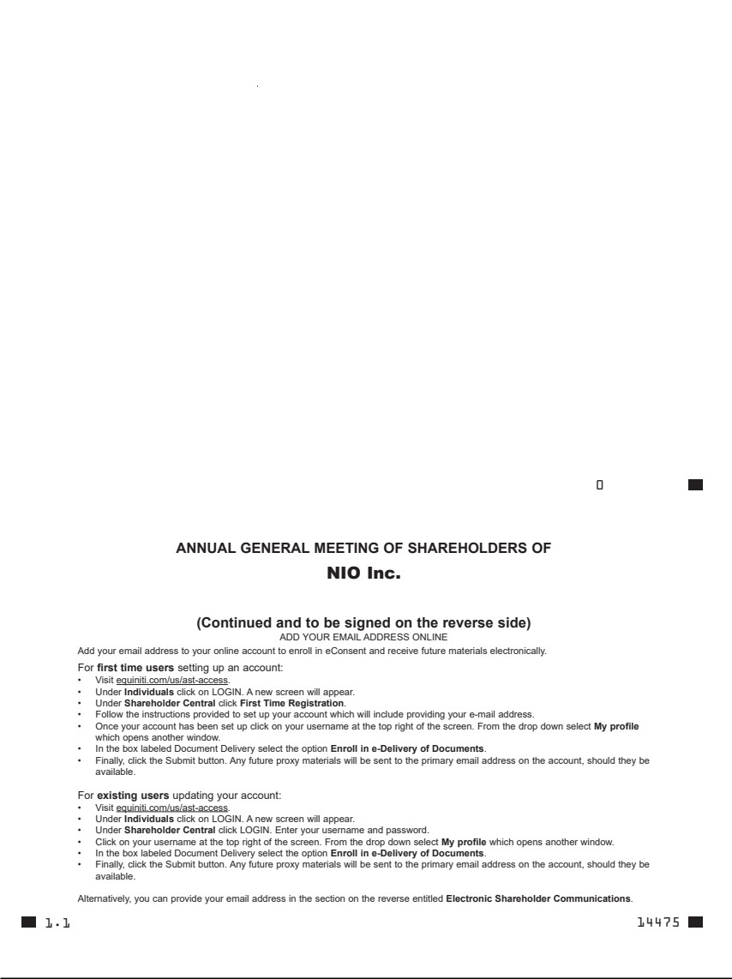

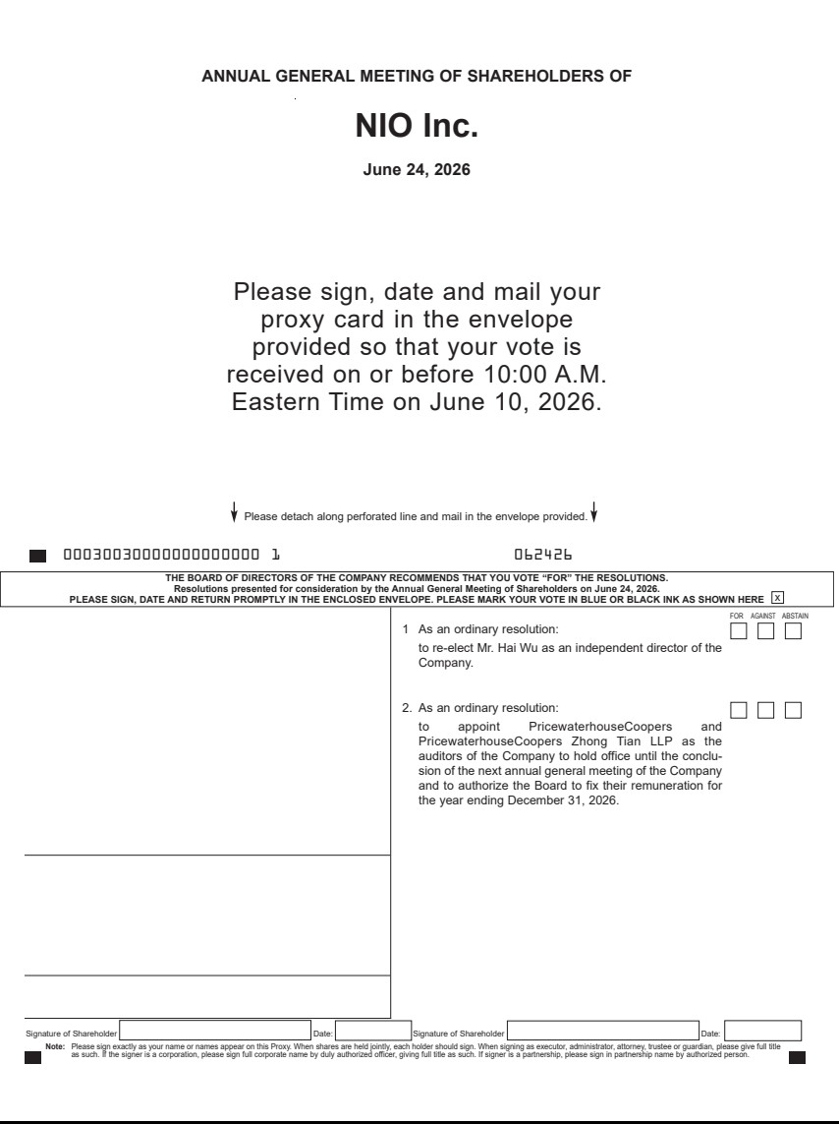

Exhibit 99.5


